**GM wants Trump administration to back national electric vehicle program**

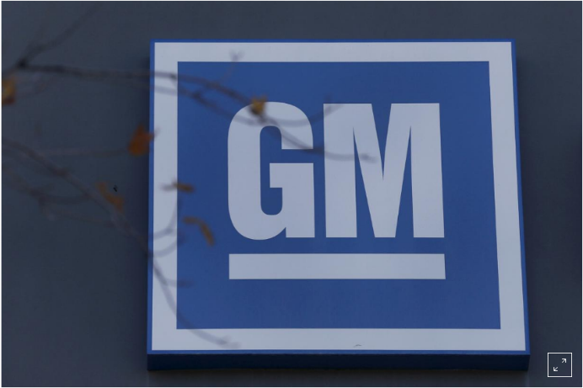WASHINGTON (Reuters) - General Motors Co said on Friday it wants the Trump administration to back a nationwide program to boost sales of zero emission vehicles like electric cars, even as the government has proposed ending California’s ability to require more clean vehicles.

GM says a nationwide program modeled on California’s effort could result in 7 million electric vehicles, or EVs, on U.S. roads by 2030. The largest U.S. automaker said the requirements would not apply if “battery cost or infrastructure targets are not practicable within the time frame.”

GM product chief Mark Reuss told reporters that governments and industries in Asia and Europe “are working together to enact policies now to hasten /ˈheɪsn/ the shift to an all-electric future. It’s very simple: America has the opportunity to lead in the technologies of the future.”

A national mandate also would create jobs and reduce fuel consumption, CO2 emissions and “make EVs more affordable,” Reuss added. GM also wants the program to offer incentives for electric autonomous /ɔːˈtɑːnəməs/ and ride-sharing vehicles.

GM has said it plans to offer 20 EVs globally by 2023.

The Trump administration in August proposed reversing /rɪˈvɜːrs/ Obama administration fuel rules and freezing standards at 2020 model year levels through 2026.

The administration has proposed barring California from setting its own emissions requirements or requiring more zero emission vehicles. The administration is also considering eliminating all emissions compliance credits that automakers receive for building EVs.

Other automakers, including Tesla Inc, did not comment on GM’s proposal. The Trump administration and California officials did not immediately comment but one environmental group called the GM proposal “a distraction.”

Luke Tonachel, director of clean vehicles and fuels at the Natural Resources Defense Council, said automakers should focus on maintaining the Obama era rules that call for hiking fuel efficiency requirements at about 5 percent annually through 2026.

Automakers and others have until Friday to file comments on the administration’s proposed emissions revisions. Major automakers say they do not support freezing requirements.

California wants 15.4 percent of vehicle sales by 2025 to be EVs or other zero emission vehicles. Nine other states, including Maryland, Massachusetts, New Jersey and New York, have adopted those requirements. In January, California Governor Jerry Brown set a target of 5 million zero-emission vehicles in California by 2030.

A nationwide ZEV plan would give automakers more flexibility to meet a single nationwide target, rather than specific state sales requirements, GM said.

California Air Resources Board chief Mary Nichols said last month the state will “continue to insist on cars that produce fewer emissions, including millions more zero-emission vehicles.”

The Trump administration criticizes California’s ZEV mandate, saying it requires automakers to spend tens of billions of dollars developing vehicles that most consumers do not want, only to sell them at a loss.

**hasten** /ˈheɪsn/ [with object] cause (something, esp. something undesirable) to happen sooner than it otherwise would

**autonomous** /ɔːˈtɑːnəməs/ self-driving

Les macarons

Une recette de macarons classique de chez Classique qui ne peut que réussir.

[chez](https://www.collinsdictionary.com/dictionary/french-english/chez) /ʃe/ at

[qui](https://www.collinsdictionary.com/dictionary/french-english/qui)/ki/ who

peut pouvoir

[que](https://www.collinsdictionary.com/dictionary/french-english/que) /kə/ that

[réussir](https://www.collinsdictionary.com/dictionary/french-english/r%C3%A9ussir) /ʀeysiʀ/ suceed

? A classic macaroon recipe from classic that can only succeed.

Préparation : 20'

20, vingt /vɛ̃/

Recette pour environ 40 macarons moyens

125 g de poudre d'amandes - 255 g de sucre glace - 3 blancs d'oeufs frais - 30 g de sucre semoule.

1 - Dessécher la poudre d'amandedans un four préchauffé à 50°C pendant une [vingtaine](https://www.collinsdictionary.com/dictionary/french-english/vingtaine) de minutes. [Sortir](https://www.collinsdictionary.com/dictionary/french-english/sortir) la [plaque](https://www.collinsdictionary.com/dictionary/french-english/plaque) [puis](https://d.docs.live.net/618f6604287d1f73/lese) laisser/lese/ [refroidir](https://www.collinsdictionary.com/dictionary/french-english/refroidir).

[dessécher](https://www.collinsdictionary.com/dictionary/french-english/dess%C3%A9cher) /deseʃe/ to dry out

[poudre](https://www.collinsdictionary.com/dictionary/french-english/poudre) /pudʀ/ powder

[amande](https://www.collinsdictionary.com/dictionary/french-english/amande) /amɑ̃d/ almond *de la pâte d’amandes (marzipan)*

vingtaine /vɛ̃tɛn/ *une vingtaine de personnes (around twenty people)*

sortir /sɔʀtiʀ/come out

plaque /plak/ plate

puis /pɥi/ then

refroidir /ʀ(ə)fʀwadiʀ/ to cool

? Remove the plate and allow to cool.

2 - [Réunir](https://www.collinsdictionary.com/dictionary/french-english/r%C3%A9unir) [*sucre glace*](https://en.wikipedia.org/wiki/Powdered_sugar) et poudre d'amande séchée et [tamiser](https://www.collinsdictionary.com/dictionary/french-english/tamiser).

Réunir /ʀeyniʀ/ combine

[glace](https://www.collinsdictionary.com/dictionary/french-english/glace) /ɡlas/ *sucre glace (icing sugar)*

tamiser /tamize/ sift

3 - [Monter](https://www.collinsdictionary.com/dictionary/french-english/monter) les blancs avec une petite [goutte](https://www.collinsdictionary.com/dictionary/french-english/goutte) de citron et [serrer](https://www.collinsdictionary.com/dictionary/french-english/serrer) au sucre (comme pour la meringue française).

monter /mɔ̃te/

goutte /ɡut/ drop

serrer /seʀe/

4 - [Incorporer](https://www.collinsdictionary.com/dictionary/french-english/incorporer) les blancs en /ɑ̃/ deux fois.

incorporer /ɛ̃kɔʀpɔʀe/ to include something so that it forms a part of something

5 - [Lorsque](https://www.collinsdictionary.com/dictionary/french-english/lorsque) la première [partie](https://www.collinsdictionary.com/dictionary/french-english/partie) des blancs n'est pas tout à [fait](https://www.collinsdictionary.com/dictionary/french-english/fait) incorporée.

lorsque /lɔʀsk/ when

partie /paʀti/ part

fait /fɛ/

6 - Incorporer le [reste](https://www.collinsdictionary.com/dictionary/french-english/reste) à la spatule, [tranquillement](https://www.collinsdictionary.com/dictionary/french-english/tranquillement). Bien [secouer](https://www.collinsdictionary.com/dictionary/french-english/secouer) la spatule que le mélange soit lisse.

reste /ʀɛst/ tranquillement

tranquillement /tʀɑ̃kilmɑ̃/ quietly

secouer /s(ə)kwe/ shake

soit /swa/

? Add the rest to the spatula, quietly. Shake the spatula well as the mixture is smooth.

7 - La macaronage c'est l'amalgame qui retombe, l'appareil est d'apparence liquide mais présente une certaine densité.

amalgame /amalɡam/mixture

appareil /apaʀɛj/mixture

8 - Coucher l'appareil selon la taille des macarons attendus sur papier sulfurisé sec.

coucher /kuʃe/ put to bed

selon /səlɔ̃/ depending on

taille /taj/ size

sulfurisé /sylfyʀize/ papier sulfurisé (greaseproof paper)

9 - Claquer doucement la plaque pour étaler l'appareil (si utile) et laisser croûter plusieurs heures à l'air libre.

claquer /klake/slam

doucement /dusmɑ̃/gentely

étaler /etale/ roll out

croûter /kʀute/ to eat

plusieurs /plyzjœʀ/ several

10 - On remarque le croûtage : la surface est sèche au doigt. Enfourner à four préchauffé à 150°C et cuire pile-poil 10 minutes.

remarque /ʀ(ə)maʀk/ remark

doigt /dwa/ finger

enfourner /ɑ̃fuʀne/ to put in an oven

pile-poil /pilpwal/ exactly

?We notice the crusting: The surface is dry on the finger. Bake in preheated oven at 150 °c and cook for 10 minutes.

11 - Rien à dire... Attendez seulement que les macarons soient refroidis pour les décoller du papier.

rien /ʀjɛ̃/ nothing

dire /diʀ/ to say

attendez /atɑ̃dʀ/ wait

seulement /sœlmɑ̃/ only

décoller /dekɔle/ remove

12 - Le macaron étant vraiment très sucré il se plaira en compagnie d'un chocolat viennois, d'un thé ou d'un expresso sans sucre.

étant /etɑ̃/

vraiment /vʀɛmɑ̃/ really

sucré /sykʀe/ sweet

compagnie /kɔ̃paɲi/ company